Curved Shapes
# Source: AI Source: Provided by: [Data Path: Persons Table -> ID Column: 1, Name_En Column: Motasem Essam] -> From: [ChatGPT] on [7/25/2026]
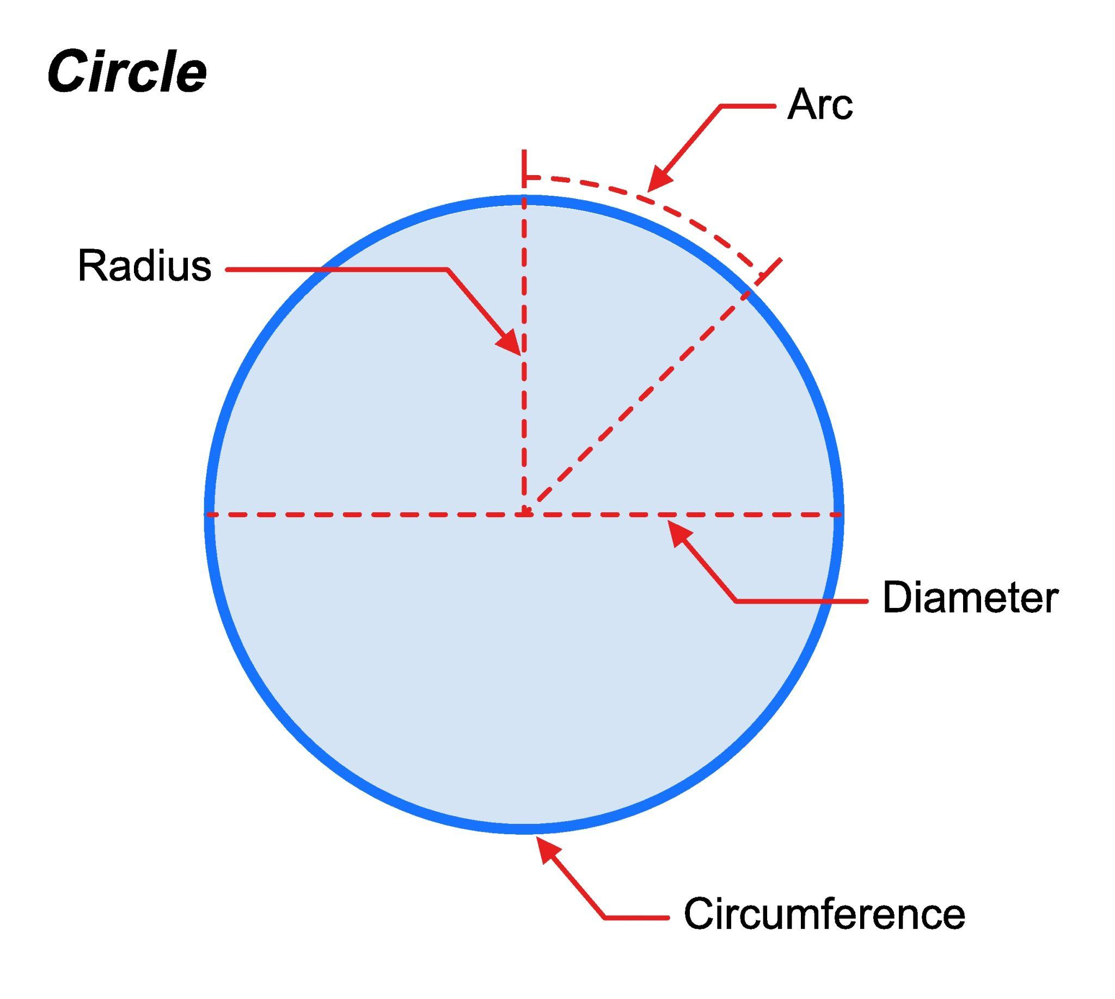
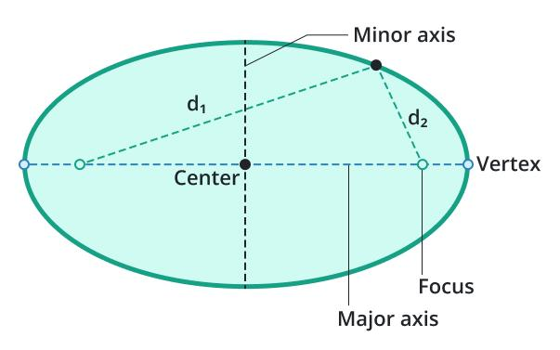
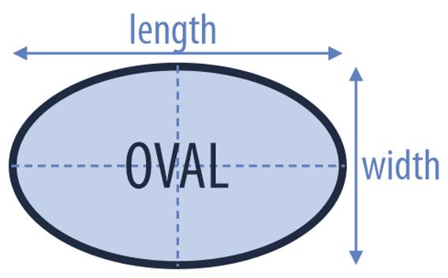
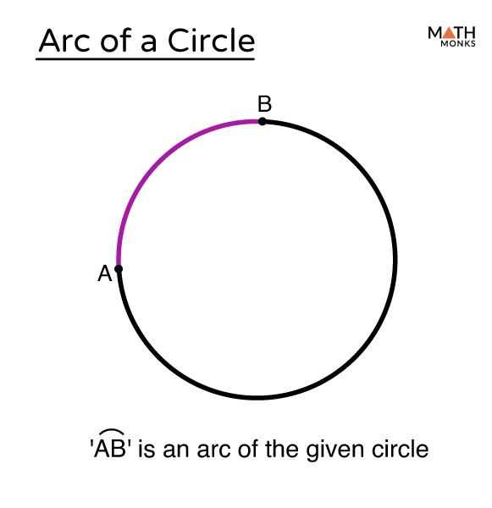
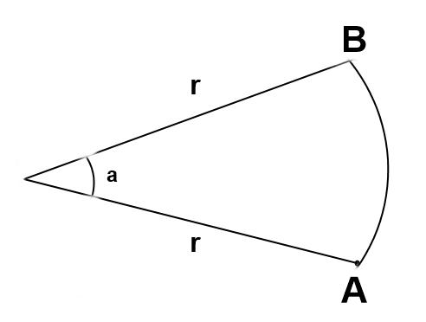

Definition
# Source: AI Source: Provided by: [Data Path: Persons Table -> ID Column: 1, Name_En Column: Motasem Essam] -> From: [ChatGPT] on [7/25/2026]
A Curved Shape is a two-dimensional geometric figure whose boundary is formed entirely by one or more curves rather than straight line segments. Unlike polygonal shapes, curved shapes have smooth boundaries with no corners or vertices (unless combined with straight edges in mixed shapes).
Curved shapes may be:
- Closed, enclosing a region (such as a circle or ellipse).
- Open, not enclosing a region (such as an arc or parabola).

Characteristics
# Source: AI Source: Provided by: [Data Path: Persons Table -> ID Column: 1, Name_En Column: Motasem Essam] -> From: [ChatGPT] on [7/25/2026]
A curved shape:
- Is two-dimensional (2D).
- Has a boundary made of curves.
- Contains no straight edges.
- May be open or closed.
- May or may not enclose a region.
- Usually has no vertices or corners.
- Has measurable perimeter (curve length) if closed.

Illustration

Circle
# Source: AI Source: Provided by: [Data Path: Persons Table -> ID Column: 1, Name_En Column: Motasem Essam] -> From: [ChatGPT] on [7/25/2026]
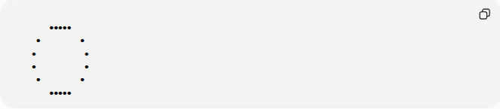
●●●●●
● ●
● ●
● ●
● ●
●●●●●
The boundary is entirely curved.

Ellipse
# Source: AI Source: Provided by: [Data Path: Persons Table -> ID Column: 1, Name_En Column: Motasem Essam] -> From: [ChatGPT] on [7/25/2026]
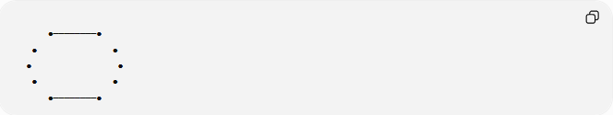
●────────●
● ●
● ●
● ●
●────────●

Arc
# Source: AI Source: Provided by: [Data Path: Persons Table -> ID Column: 1, Name_En Column: Motasem Essam] -> From: [ChatGPT] on [7/25/2026]
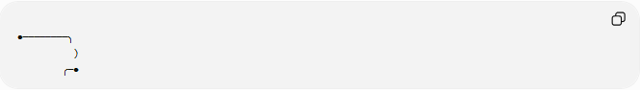
●────────╮
)
╭─●
An arc is an open curved shape because it does not form a closed loop.

Mathematical Representation
# Source: AI Source: Provided by: [Data Path: Persons Table -> ID Column: 1, Name_En Column: Motasem Essam] -> From: [ChatGPT] on [7/25/2026]
Curved shapes are often represented by equations.
Circle
$$x^{2}+y^{2}=r^{2}$$

Ellipse
$$\frac{x^{2}}{a^{2}}+\frac{y^{2}}{b^{2}}=1$$

Parabola
$$y=x^{2}$$

Hyperbola
$$\frac{x^{2}}{a^{2}}-\frac{y^{2}}{b^{2}}=1$$

Common Curved Shapes
# Source: AI Source: Provided by: [Data Path: Persons Table -> ID Column: 1, Name_En Column: Motasem Essam] -> From: [ChatGPT] on [7/25/2026]
1. Circle
All boundary points are equally distant from the center.

2. Ellipse
An elongated closed curve.

3. Oval
A smooth closed curve that resembles an ellipse but may not follow a standard mathematical equation.

4. Arc
Part of a circle.

5. Parabola
An open curve extending infinitely.

6. Hyperbola
An open curve with two separate branches.

Closed vs Open Curved Shapes

Closed Curved Shapes
# Source: AI Source: Provided by: [Data Path: Persons Table -> ID Column: 1, Name_En Column: Motasem Essam] -> From: [ChatGPT] on [7/25/2026]
Examples:
- Circle
- Ellipse
- Oval
These enclose a bounded region.

Open Curved Shapes
# Source: AI Source: Provided by: [Data Path: Persons Table -> ID Column: 1, Name_En Column: Motasem Essam] -> From: [ChatGPT] on [7/25/2026]
Examples:
- Arc
- Parabola
- Hyperbola
These do not enclose a region by themselves.

Properties
# Source: AI Source: Provided by: [Data Path: Persons Table -> ID Column: 1, Name_En Column: Motasem Essam] -> From: [ChatGPT] on [7/25/2026]
1. Smooth Boundary
The boundary changes direction continuously.

2. No Straight Edges
Entirely composed of curves.

3. Usually No Vertices
Unlike polygons, curved shapes generally have no corners.

4. May Enclose Area
Only closed curved shapes enclose measurable area.

Real-World Examples
# Source: AI Source: Provided by: [Data Path: Persons Table -> ID Column: 1, Name_En Column: Motasem Essam] -> From: [ChatGPT] on [7/25/2026]
Curved shapes appear in:
- Coins.
- Wheels.
- Plates.
- Clocks.
- Stadium tracks.
- Domes.
- Eggs.
- Planets.
- Lenses.
- Bubbles.

Applications
# Source: AI Source: Provided by: [Data Path: Persons Table -> ID Column: 1, Name_En Column: Motasem Essam] -> From: [ChatGPT] on [7/25/2026]
Curved shapes are used in:
- Plane Geometry
- Coordinate Geometry
- Analytic Geometry
- Differential Geometry
- Engineering
- Architecture
- Mechanical Design
- Industrial Design
- CAD (Computer-Aided Design)
- Computer Graphics
- Optics
- Astronomy

Advantages
# Source: AI Source: Provided by: [Data Path: Persons Table -> ID Column: 1, Name_En Column: Motasem Essam] -> From: [ChatGPT] on [7/25/2026]
Studying curved shapes helps to:
- Model natural objects.
- Describe circular motion.
- Compute area and circumference.
- Analyze smooth boundaries.
- Design curved engineering structures.

Limitations
# Source: AI Source: Provided by: [Data Path: Persons Table -> ID Column: 1, Name_En Column: Motasem Essam] -> From: [ChatGPT] on [7/25/2026]
Curved shapes:
- Often require calculus for advanced analysis.
- Are generally more difficult to describe than polygons.
- May require approximation methods in computation.

Comparison with Other Shape Types
# Source: AI Source: Provided by: [Data Path: Persons Table -> ID Column: 1, Name_En Column: Motasem Essam] -> From: [ChatGPT] on [7/25/2026]
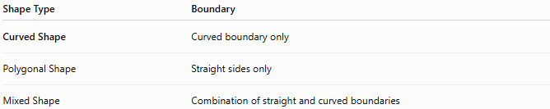
Shape Type | Boundary
Curved Shape | Curved boundary only
Polygonal Shape | Straight sides only
Mixed Shape | Combination of straight and curved boundaries

Key Points
# Source: AI Source: Provided by: [Data Path: Persons Table -> ID Column: 1, Name_En Column: Motasem Essam] -> From: [ChatGPT] on [7/25/2026]
- A Curved Shape has a boundary formed entirely by curves.
- It may be:
  - Open.
  - Closed.
- Common curved shapes include:
  - Circle.
  - Ellipse.
  - Oval.
  - Arc.
  - Parabola.
  - Hyperbola.
- Closed curved shapes enclose measurable regions.

Conclusion
# Source: AI Source: Provided by: [Data Path: Persons Table -> ID Column: 1, Name_En Column: Motasem Essam] -> From: [ChatGPT] on [7/25/2026]
A Curved Shape is a two-dimensional geometric figure whose boundary consists entirely of smooth curves instead of straight line segments. Curved shapes include figures such as circles, ellipses, ovals, arcs, parabolas, and hyperbolas, and they are fundamental in plane geometry, coordinate geometry, analytic geometry, differential geometry, engineering, architecture, mechanical design, industrial design, CAD, computer graphics, optics, and astronomy, where they are used to model natural forms, analyze smooth boundaries, and design curved structures and objects.

